Given the root of a binary tree, return *all root-to-leaf paths in****any order***.

A **leaf** is a node with no children.

**Example 1:**

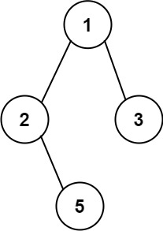

**Input:** root = [1,2,3,null,5]

**Output:** ["1->2->5","1->3"]

**Example 2:**

**Input:** root = [1]

**Output:** ["1"]

**Constraints:**

* The number of nodes in the tree is in the range [1, 100].
* -100 <= Node.val <= 100